










https://www.politico.com/news/2026/05/16/ballroom-funding-senate-parliamentarian-00924612

HEADLINES

Ballroom security money nixed by Senate parliamentarian

Republicans proposed sending $1 billion to the Secret Service, with some to be used on the controversial White House project.
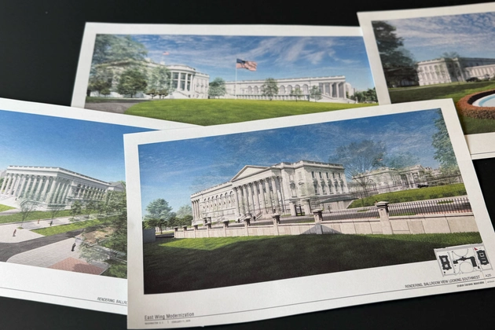
Artist renderings of the new White House East Wing and Ballroom are photographed Tuesday, March 31, 2026. (AP Photo/Jon Elswick) | AP
By Jordain Carney05/16/2026 09:52 PM EDTUpdated: 05/16/2026 10:20 PM EDT

President Donald Trump’s hopes of using public funding to secure his proposed White House ballroom are under threat after a Senate official said Saturday a $1 billion Secret Service line item could not be included in a GOP immigration enforcement bill as drafted.
Elizabeth MacDonough, the chamber’s parliamentarian, ruled that the language aimed at enhancing Secret Service security measures would need to be reworked if Republicans want to pass the larger bill along party lines as planned, according to a statement from Budget Committee Democrats.

MacDonough, the Democrats said, struck the entire Secret Service provision because it included funding that fell outside of the jurisdiction of the Judiciary Committee, which included the language in their portion of the immigration enforcement bill. The administration estimated that approximately $220 million of the $1 billion would go toward the White House construction project.

“While we expect Republicans to change this bill to appease Trump, Democrats are prepared to challenge any change to this bill,” Sen. Jeff Merkley (D-Ore.), the top Budget Committee Democrat, said in a statement Saturday.
Senate Minority Leader Chuck Schumer added that “Democrats will keep fighting this every way we can — in the Byrd Bath, on the Senate floor with votes, and anywhere else Republicans try to raid Americans’ hard-earned money for Trump’s gilded palace.”
It’s a setback for Senate GOP leaders, who had voiced confidence they would be able to get the blessing of the chamber’s rulekeeper. But Republicans said Friday they are already working to redraft the language, which will need to be resubmitted for MacDonough’s approval.
“Conversations and revisions are continuing, as they have been for days,” a spokesperson for Judiciary Committee Republicans said in a statement Saturday night.
Ryan Wrasse, a spokesperson for Majority Leader John Thune, added on X: “Redraft. Refine. Resubmit. None of this is abnormal during a Byrd process.”
Some Republicans believed she might object only to the specific references to the East Wing Modernization Project or to a restriction against using the funding for “non-security” purposes while keeping the $1 billion otherwise intact. Others had warned the entire proposal could fall and held off on taking a position for or against the funding until MacDonough ruled.
GOP leaders have already faced pushback from members in both chambers, with some senators already discussing possible changes to the request as they waited to see how MacDonough would rule. Senate Majority Leader John Thune said in a Thursday interview that leaders were “hearing members out” and the conversations were about “how do we get 50 votes in the Senate for something.”
Republicans will need to move quickly to regroup or they risk missing Trump’s self-imposed June 1 deadline to get a bill to his desk. Senate Republicans are aiming to pass the bill no later than Friday, sending it to the House before a weeklong recess.
MacDonough’s decision on the ballroom-related language comes after she ruled Thursday against four other parts of the immigration enforcement bill, which will provide tens of billions in new funding for agencies including Immigration and Customs Enforcement.
Jennifer Scholtes contributed to this report.

